**Protein-Protein Interactions and Identification of Hub Genes**

The DEGs identified were utilized as input in the STRING database, which encompasses protein-protein interaction (PPI) information derived from diverse sources, including databases, literature, and experimental validation. The PPIs were extracted from STRING using default parameters and subsequently employed as input in Cytoscape, a popular software platform for visualizing and analyzing biological networks. In Cytoscape, the CytoHubba module was utilized to identify the top 10 hub genes from the PPI network. Hub genes were determined based on their degree of centrality, which reflects the number of connections (edges) each gene has with other genes within the network. Genes with a higher degree centrality are considered more central to the network, suggesting their potential importance in regulating biological processes related to the analyzed condition or disease.

**Results**

**Protein-Protein Interactions and Hub Genes Identification**

Through the STRING database, PPIs of the dysregulated genes were predicted. These PPIs provide valuable information about the functional relationships and potential interactions among the dysregulated genes. The network analysis of the dysregulated genes is presented in **Figure 1**. These network visualizations illustrate the connections and interactions between the dysregulated genes, highlighting their complex relationships within MM.

Furthermore, based on the network analysis results, the top 10 hub genes were identified, as shown in **Table 1**. These hub genes play crucial roles in the network and are likely to have significant functional and regulatory implications. The top 5 highly interconnected genes are IL1B, CD4, ITGAM, PTPRC and TYROBP.

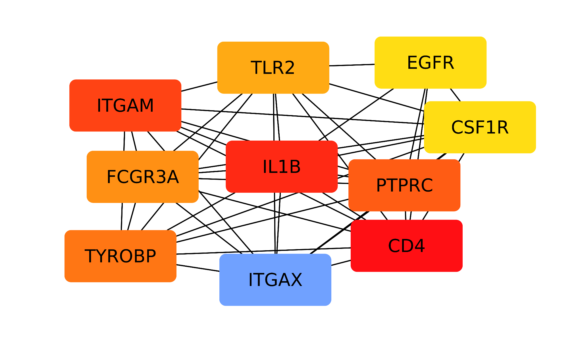

**Figure 23.** Top 10 hub genes in RNA-seq based dysregulated genes identified through protein-protein interaction network analysis. The darker color represents more interactions within the same network.